**Politecnico di Milano**

**Department of Energy - *School of Industrial and Information Engineering***

Course: Renewables and Environmental Sustainability

Academic Year 2019/20



**OpenStudio Project**

Valentina Caia

Nicoletta Defranceschi

Lorenzo Siboni

**Introduction**

The main purpose of the project is to analyse the heating and cooling consumption of a designed building, placed in a specific city. In particular, we have done the analysis for three cities: Milan, Rome and Catania. The choice is based on the fact that we want to have a sort of overall view on consumptions in the North, Centre and South of Italy and the main differences regarding the temperature ranges throughout the year.

First of all, the base case is set in Rome. Then we have made a comparison with the buildings placed in Milan and Catania, changing also the construction characteristics.

**Building design**

In order to build our model we have used *SketchUp 2016*, a program that allows to draw the model of the building, set the geometrical features, define the various spaces and the future use of it.

We have drawn a building with an area of 30x40 m2. The roof has been realized with an offset of 10 m.

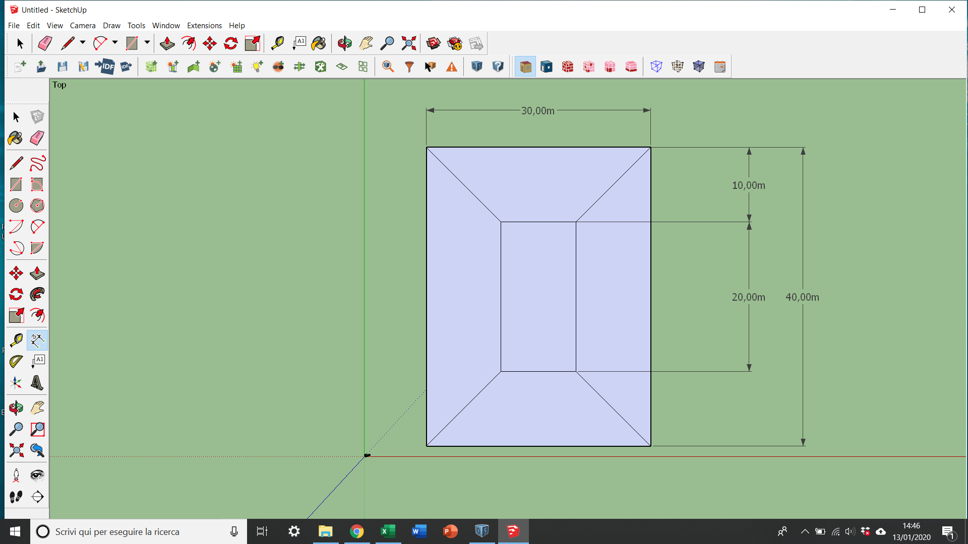

The building has two floors. The windows are characterized by a window over wall ratio of . The overhangs are placed all around the building, except for the north side. They have a projection factor equal to 0,6.

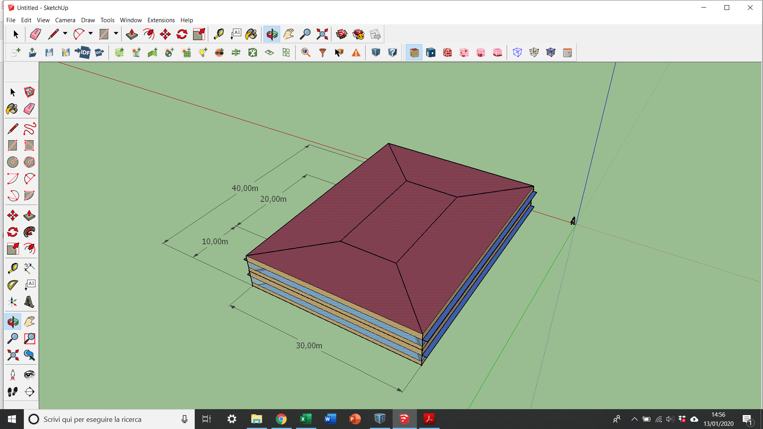

Next, we have defined three main thermal zones:

1. The spaces at first floor represent the thermal zone 1.

* Space type: *189.1-2009-Office-OpenOffice-CZ1-3*;
* Costruction Set: *189.1-2009-CZ1-Office*;
* Thermostat: *189.1-2009-Office-OpenOffice-CZ1-3 Thermostat*.

1. The spaces at the second floor represent the thermal zone 2.

* Space type: *189.1-2009-Office-OpenOffice-CZ1-3*;
* Costruction Set: *189.1-2009-CZ1-Office*;
* Thermostat: *189.1-2009-Office-OpenOffice-CZ1-3 Thermostat*.

1. The two spaces inside the building represent the thermal zone 3.

* Space type: *189.1-2009-Office-Stair-CZ1-3*;
* Costruction Set: *189.1-2009-CZ1-Office*;
* Thermostat: *189.1-2009-Office-Stair-CZ1-3 Thermostat.*

Once we have designed the building we moved to *OpenStudio*.

**OpenStudio Project**

First we set the weather data: our base case is Rome. We maintain the standard construction set and we don’t change anything in the external wall materials and windows specifics.

The external walls are characterized, starting from the outside surface, by:

* 1 IN Stucco
* 8 IN Concrete HW
* Wall Insulation [31]
* ½ IN Gypsum

The windows are made of theoretical glass [167].

We run the simulation and we obtain the following results:

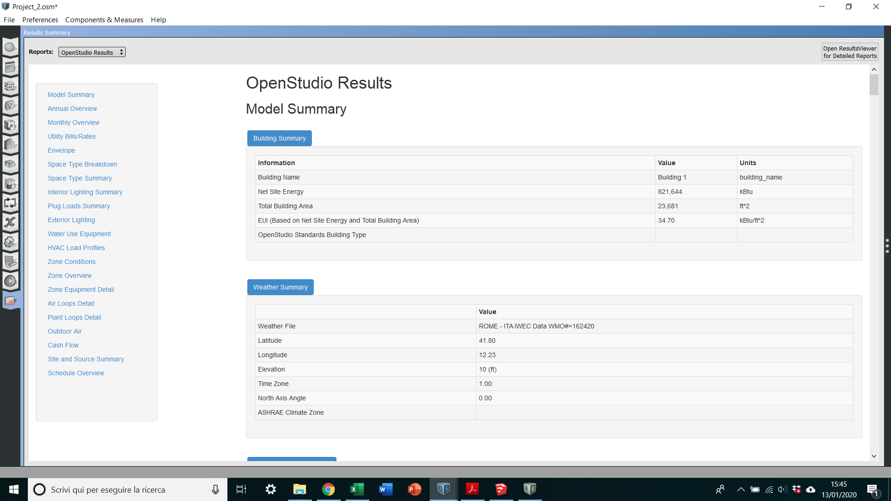

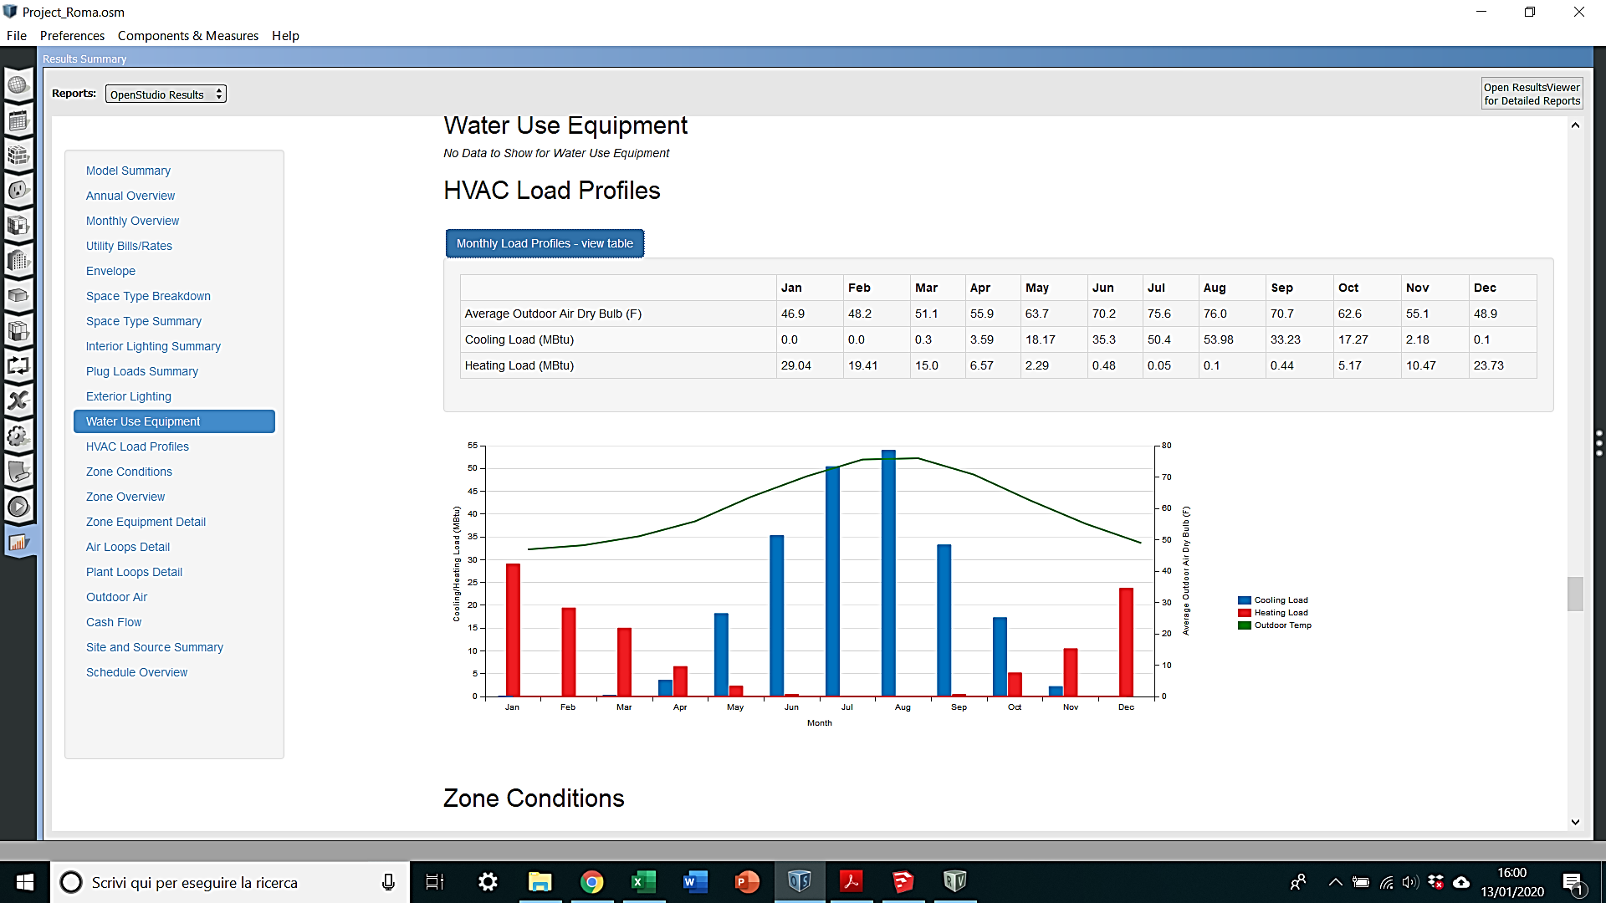

The second case study is Milan. We change the characteristics of the construction set: it has been named as *Milan Model* and the materials used for the external walls are:

* 1 IN Stucco
* 8 IN Concrete HW
* **Wall Insulation [44]**
* **Wall Air Space**
* **19 mm Gypsum board**

The windows are composed by theoretical glass [207].

By running the simulation we obtain the following results:

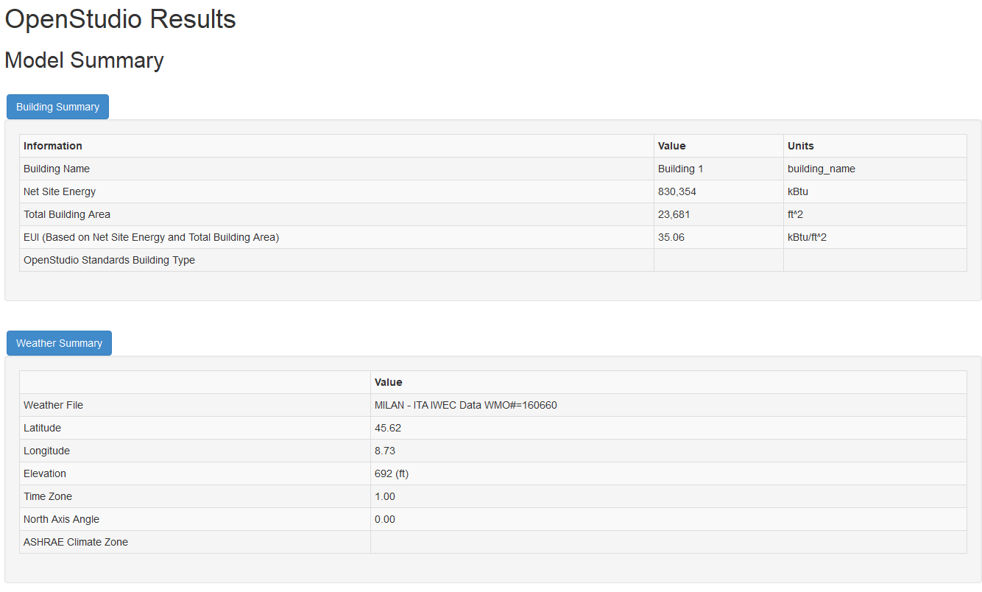

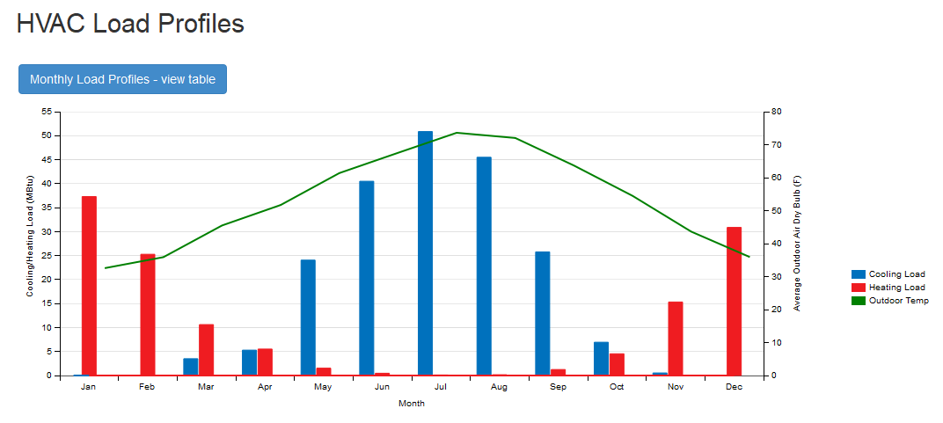

The last analysis is conducted in Catania, in the South of Italy. The materials of the external walls are:

* 1 IN Stucco
* 8 IN Concrete HW
* **Wall Insulation [31]**
* **Wall Air Space**
* **½ IN Gypsum**

The windows are made of theoretical glass [167].

After running the simulation, we obtain the following results:

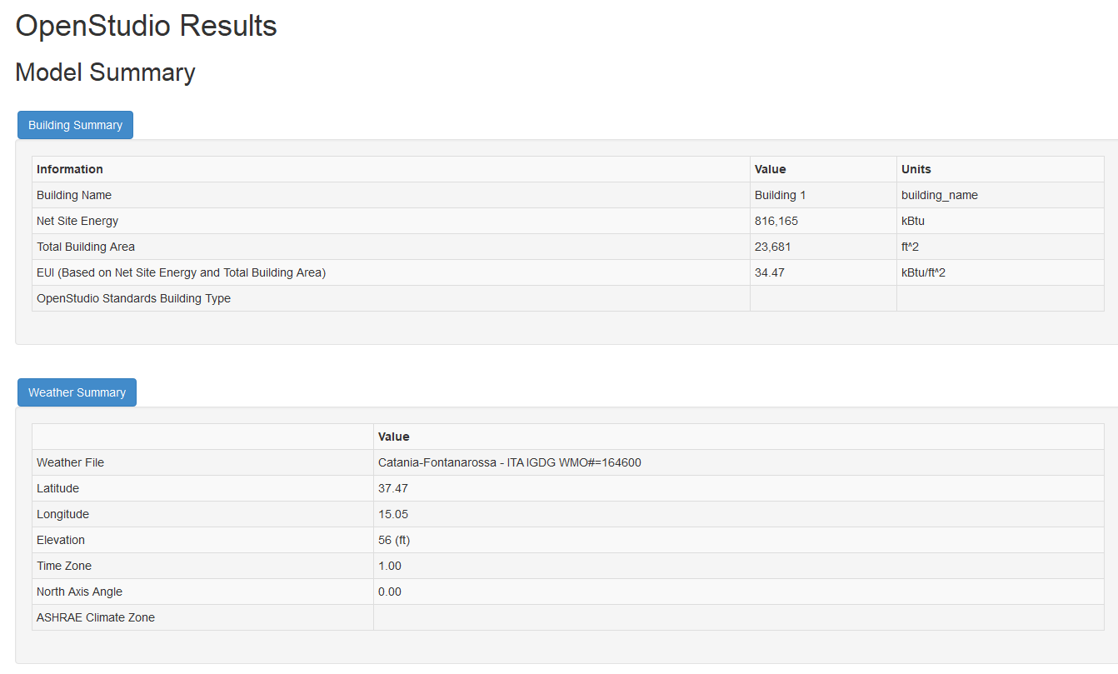

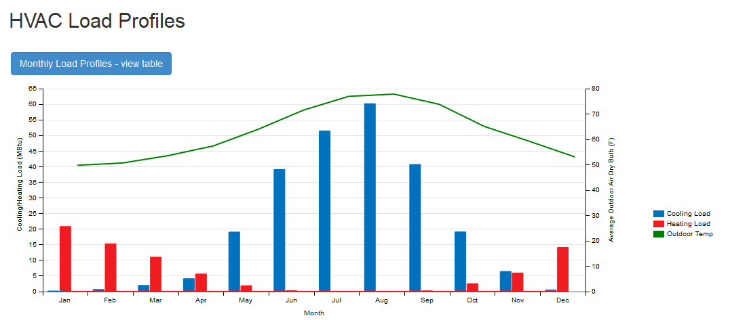

In the table below the values of heating consumption relative to the three cities are reported:

|  |  |  |  |
| --- | --- | --- | --- |
|  | Heating – Rome  [J] | Heating – Milan  [J] | Heating – Catania [J] |
| January | 0,306371E+11 | 0,393638E+11 | 0,219955E+11 |
| February | 0,204810E+11 | 0,266627E+11 | 0,161556E+11 |
| March | 0,158213E+11 | 0,112025E+11 | 0,116491E+11 |
| April | 0,693334E+10 | 0.581814E+10 | 0,596314E+10 |
| May | 0,241404E+10 | 0,161473E+10 | 0,201198E+10 |
| June | 0,507831E+09 | 0,501314E+09 | 0,312814E+09 |
| July | 56293721,98 | 0,118062E+09 | 69414739,13 |
| August | 0,107931E+09 | 0,171612E+09 | 53303380,07 |
| September | 0,469470E+09 | 0,132046E+10 | 0,270226E+09 |
| October | 0,545363E+10 | 0,478391E+10 | 0,269096E+10 |
| November | 0,110489E+11 | 0,161710E+11 | 0,628102E+10 |
| December | 0,250342E+11 | 0,325735E+11 | 0,149589E+11 |
|  |  |  |  |
| Annual sum or average | 0,118965E+12 | 0,140302E+12 | 0,824119E+11 |
| Minimum of Months | 56293721,98 | 0,118062E+09 | 53303380,07 |
| Maximum of Months | 0,306371E+11 | 0,393638E+11 | 0,219955E+11 |

In the following table the values for the cooling consumptions are shown:

|  |  |  |  |
| --- | --- | --- | --- |
|  | Cooling – Rome  [J] | Cooling – Milan  [J] | Cooling – Catania [J] |
| January | 0,00 | 0,00 | 0,21555E+09 |
| February | 0,00 | 59658136,09 | 0,729017E+09 |
| March | 0,311402E+09 | 0,369621E+10 | 0,210319E+10 |
| April | 0,378754E+10 | 0,558461E+10 | 0,438739E+10 |
| May | 0,191743E+11 | 0,253787E+11 | 0,201308E+11 |
| June | 0,372419E+11 | 0,427264E+11 | 0,412645E+11 |
| July | 0,531717E+11 | 0,536582E+11 | 0,543006E+11 |
| August | 0,569570E+11 | 0,480043E+11 | 0,635083E+11 |
| September | 0,350634E+11 | 0,271945E+11 | 0,429610E+11 |
| October | 0,182184E+11 | 0,732123E+10 | 0,201704E+11 |
| November | 0,230194E+10 | 0,563075E+10 | 0,681235E+10 |
| December | 0,106992E+09 | 0,00 | 0,520944E+09 |
|  |  |  |  |
| Annual sum or average | 0,226335E+12 | 0,214187E+12 | 0,257104E+09 |
| Minimum of Months | 0,00 | 0,00 | 0,21555E+09 |
| Maximum of Months | 0,569570E+11 | 0,536582E+11 | 0,635083E+11 |

From the tables of the heating loads, we can state that the higher values occur in Milan and that the difference between the maximum value of Milan and the base case is about 28%. Regarding the cooling loads, instead, the higher value is obtained in Catania, having a difference of roughly 11% with respect to Rome.

Finally, we have also created a second model for Milan but maintaining the same construction sets of Rome. The results regarding the heating loads are:

|  |  |  |
| --- | --- | --- |
|  | Heating – Milan – CZ1-3  [J] | Heating – Milan – Milan Model [J] |
| January | 0,773115E+11 | 0,393638E+11 |
| February | 0,568219E+11 | 0,266627E+11 |
| March | 0,269066E+11 | 0,112025E+11 |
| April | 0,142186E+11 | 0.581814E+10 |
| May | 0,370885E+10 | 0,161473E+10 |
| June | 0,991690E+09 | 0,501314E+09 |
| July | 0,157159E+09 | 0,118062E+09 |
| August | 0,228906E+09 | 0,171612E+09 |
| September | 0,248682E+10 | 0,132046E+10 |
| October | 0,952434E+10 | 0,478391E+10 |
| November | 0,369001E+11 | 0,161710E+11 |
| December | 0,649560E+11 | 0,325735E+11 |
|  |  |  |
| Annual sum or average | 0,294212E+12 | 0,140302E+12 |
| Minimum of Months | 0,157159E+09 | 0,118062E+09 |
| Maximum of Months | 0,773115E+11 | 0,393638E+11 |

The modified construction set has permitted to decrease the heating load for the building in Milan and this is a positive aspect of the project. To this purpose, it is possibile to say that there are more than one parameter which can influence the heating and cooling load, not only the outdoor temperature. In our case study, the materials, in the construction set, used for the external walls of the building are decisive in determining the difference among the three models.